2022 California State Championships Entry Form
Sponsor: Southern California Horseshoe Pitchers Association (SCHPA)
Host Club: Bakersfield Shoe Crew
3-4 September 2022

Beach Park, Bakersfield, California
Added prize money from local sponsors! Prize money available to Cadet and Junior players!!!

NHPA #: Name: Phone:

Address: City: CA ZIP:

Birth Date: E-Mail:

How do you want your pitching schedule sent? Please circle one: E-Mail US Postal Service
Select Your Entry Division (circle one):

Open Men (40ft) Sr. Men (40ft) Elders or Med Exempt (30ft) Open Women Sr. Women

Jr. Boys (30ft) Jr. Girls (30ft) Jr. Cadet Boys (20ft) Jr. Cadet Girls (20ft)
For Cadets and Juniors, do you want to participate with the prize money awards? Circle either: Yes or No
If yes, we require parental approval: ___________________________________ (parent’s signature)
Participant Liability Release: All applicant information and signature are required. In consideration of participating in this tournament, I hereby waive, release, and forever discharge the NHPA, SCHPA, and NCHPA, all officers, employees, agents, and servants of the afore stated organizations, and all fellow participants of this event, for any and all action, cause of action, damage, loss or injury, which I may suffer as a consequence of participating in the California State Horseshoe Pitching Championships. In addition, it is understood that the SCHPA and NCHPA have sole rights to any and all pictures and/or articles for publication.

Applicant’s Signature: Date:
----------cut here----------------------------------------------cut here-----------------------------------cut here-----------------------------------
(Keep this section for future reference – Calif. State Championships, Bakersfield, 3-4 September 2022)

Adult entrants MUST have at least 3 sanctioned California tournaments recorded in nhpa-eshoe.com during the 12 months prior to the entry deadline date; for cadet or junior entrants, at least 1 sanctioned California tournament recorded in nhpa-eshoe.com as of the entry deadline date.

For a division with less than six entries, the tournament committee reserves the right to combine the division with another division with the same pitching distance.

Entrants must wear shirts with their name professionally printed on the back; do not rely on purchased shirts at the tournament because the vendor cannot guarantee timely deliveries.

Entry fee is $40.00 for adults and FREE for juniors and cadets; no refunds after the below entry deadline date. All championship classes will have similar payouts and all lower level classes will have similar payouts.

Entry deadline date (or post mark date): 1 August 2022 (Late entries require an additional $10 entry fee and will be used on a standby basis only.)

Make checks payable to: S C H P A

Send entries to: Hal Griswold (949/496-0577 or setibird@yahoo.com)
32612 Balearic Road
Dana Point CA 92629

If you must drop out, please immediately notify Hal Griswold (949/496-0577 or setibird@yahoo.com).

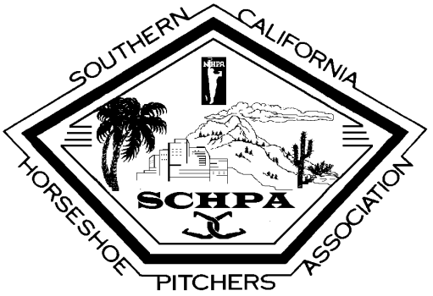

2022 California State Horseshoe Pitching Championships

Awards Sponsor Form

The Southern California Horseshoe Pitchers Association (SCHPA) will host the 2022 California State Horseshoe Pitching Championships at the Bakersfield Shoe Crew Horseshoe Pitching Club, Beach Park, Bakersfield, California, during the 3-4 September weekend. Please consider sponsoring an award for this prestigious event! Both plaques and cash are awarded to the winners of 15-20 player groups from throughout the State of California. This tournament establishes California State Horseshoe Pitching Champions for both men and women of all ages plus boys and girls less than 19 years old. If you wish to sponsor a first or second place plaque award, each plaque costs about $50. If we receive your plaque sponsorship by the 15th of August, the award plaque will reflect your support. The SCHPA is a not-for-profit association and 100% of your donation goes towards the awards.

Sponsor’s Name (business, club, or person):

Sponsor’s Address:

Sponsor’s Phone and/or Email:

Donation Amount: $

Please make your donation check payable to SCHPA (a section 501(c)(4) tax exempt organization) and mail it along with this completed form to the SCHPA Secretary/Treasurer:
Hal Griswold
32612 Balearic Rd.
Dana Point CA 92629
949/496-0577 or setibird@yahoo.com

Thank you for your support!!!

